Questions to be addressed
- Kalpana: How to get odd ratio and risk ratio from previous study….plzz show from any published paper…..
https://pmc.ncbi.nlm.nih.gov/articles/PMC5305089/
https://pubmed.ncbi.nlm.nih.gov/10994260/
https://pmc.ncbi.nlm.nih.gov/articles/PMC5305089/
- Meghna Sethi: How to calculate sample size for RCT with 3 groups
Sol
- Decide: continuous (means) or categorical (proportions).
- Choose primary comparison: overall omnibus (ANOVA/chi-square) or a prespecified pairwise contrast.
- Choose alpha (0.05) and desired power (0.80/0.90).
- Specify effect size:
For continuous: either give expected means and SD → compute f, or pick Cohen’s f (0.10/0.25/0.40).
For proportions: give expected p_i → compute w, or pick effect (small/med/large) with Cohen’s w (0.10/0.30/0.50).
- Use software to solve for n:
G*Power: Test family = F → ANOVA: fixed effects, one-way.
Or solve numerically with the noncentral F / noncentral χ² formula.
R: pwr::pwr.anova.test(k=3, f=0.25, sig.level=0.05, power=0.8) → returns n per group.
- Inflate for expected loss to follow-up: $n_{\text{adjusted}}=n/(1-\text{dropout\%})$.

- Rkashala Ashalata: Please share the reference books
Recommended books
- Sample Size Determination and Power (Wiley) — a comprehensive modern treatment of sample size and power in many settings (continuous, categorical, survival). Wiley Online Library+1
- Determining Sample Size and Power in Research Studies (Springer) — this is more focused on research studies (including health/biomed) and gives guiding procedures (with screenshots of software like G*Power) for sample size/power. SpringerLink
- Sample Size Calculations: Practical Methods for Engineers and Scientists (Mathews, Malnar & Bailey, 2010) — although this has an engineering/science slant, it provides many worked methods for means/proportions/regressions etc, good for getting deep methods.
- Sample Size Determination in Health Studies: A Practical Manual (WHO/Health Studies manual) — more applied, particularly useful in health research / epidemiology / survey contexts. Iris
- Statistical Power Analysis for the Behavioral Sciences (Jacob Cohen) — a classic for effect size/power issues, good especially for continuous outcomes / behavioural-science settings (many of the same principles apply in medical research).

- Hima Ann Isaac: What are your thoughts on G power software for sample size calculations?

Yes, G*Power is a free, open-source statistical software used for power analysis. It is available for both Windows and Mac operating systems and can be downloaded from the official website.
- Hitesh: Plz share few reference book/books ?
- Preetha Ramprasat: How to calculate sample size if previous data is unavailable; or from previous mean values, standard deviation values, confidence interval?

Ans: If previous studies/data is not available, then use your judgement for the mean values or take 50% mean values etc. Confidence level take 95%.
- Preetha Ramprasat: Confidence level vs. confidence interval - pls explain once again
Sol: 1. Confidence Level — the probability or degree of certainty
The confidence level is the degree of confidence (usually expressed as a percentage) that the confidence interval you calculate will contain the true population parameter (like a mean, proportion, risk, or odds ratio).
It reflects how confident you want to be in your estimate.
Typical values:
90%
95% (most common in health research)
99%
Meaning:
If you repeated your study 100 times, and each time you computed a 95% CI, about 95 of those intervals would contain the true value of the parameter.
Example:
Confidence level = 95% → means 5% chance (α = 0.05) that your CI does not include the true value.
2. Confidence Interval — the range of plausible values
The confidence interval (CI) is the actual numerical range calculated from your sample data that is likely to contain the true population value, given your chosen confidence level.
It shows the precision of your estimate.
Example:
A study finds mean fasting blood sugar = 110 mg/dL with a 95% CI: 102 – 118 mg/dL.
Interpretation:
We are 95% confident that the true mean fasting blood sugar in the population lies between 102 and 118 mg/dL.
Narrow CI → more precise (larger sample, less variability)
Wide CI → less precise (small sample, high variability)

- Preetha Ramprasat: Pls show some research paper to understand how to look for the estimates and use for new study
https://pmc.ncbi.nlm.nih.gov/articles/PMC7831224/
- Vinu Vijayakumar: RCT with three groups?
Sol: Choose primary hypothesis (ANOVA vs pairwise).
Set α and power. Decide whether to correct for multiple comparisons.
Estimate SD (or baseline proportion) from pilot/literature.
Choose clinically meaningful Δ (difference).
Compute n using two-sample formula (shown) or use G*Power for ANOVA.
Inflate for dropout and cluster design if needed.

- Preetha Ramprasat: What is ideal d value? I have seen 5 and 10%
Ans: Ideal d (Margin of error) value is 5%
- Madhuri Marathe: What if there are no controls and we just want to see correlation and regression?
Sol: Sample size to detect a Pearson correlation (Fisher z method)
Use the Fisher z transform. If you want to detect a true correlation $r$(vs null $r_{0}$, often 0) with two-sided α and power $1-β$:
- Compute $z_{r}=\frac{1}{2}ln⁡\text{ ⁣}(\frac{1+r}{1-r})$and $z_{r_{0}}=\frac{1}{2}ln⁡\text{ ⁣}(\frac{1+r_{0}}{1-r_{0}})$.
- Let $Z_{1-α/2}$and $Z_{1-β}$be the standard normal critical values.
- Required sample size:
$$\boxed{n = 3 + \frac{(Z_{1-α/2}+Z_{1-β})^{2}}{(z_{r}-z_{r_{0}})^{2}}}$$
If $r_{0}=0$, $z_{r_{0}}=0$and formula simplifies.
Worked example. Want to detect $r=0.30$, α=0.05, power=0.80:
- $z_{r}=0.5ln⁡\frac{1+0.3}{1-0.3}=0.3095$
- $Z_{1-α/2}=1.96, Z_{1-β}=0.842$
- $n≈3+(1.96+0.842)^{2}/(0.3095)^{2}≈85$
So ≈85 subjects are needed to detect r=0.30 with 80% power.

- Pothiraj Pitchai: I need to have one clarification: one of my research is experimental design for slow learners among medical students. slow learners are the one who failed less than 50%. in this case how to do sample size calculation? kindly take this question
Sol: First choose the outcome & design
Which of the following best matches your study? (I’ll cover both so you can pick)
- Binary outcome (pass vs fail) after intervention — typical for remediation: you compare proportion passing in Intervention vs Control (two-arm RCT).
- Continuous outcome (test score) — compare mean post-test scores (or change in score) between groups.
- Pre–post single group (no control) — you measure change in the same students before/after intervention (paired test).
- Clustered groups / classroom randomisation — adjust for ICC (design effect).
Below I give formulas & examples for (1) and (2), and short notes for (3) & (4).
B. Formulas you’ll use (equal allocation, two groups)
1) For comparing two proportions (pass rates)
For equal sized groups, an accepted formula is:
$$n_{\text{per group}} = \frac{[Z_{1-α/2}\sqrt{2\overset{ˉ}{p}(1-\overset{ˉ}{p})} + Z_{1-β}\sqrt{p_{1}(1-p_{1})+p_{2}(1-p_{2})}]^{2}}{(p_{1}-p_{2})^{2}}$$
where
- $p_{1}$= control group proportion (baseline pass rate),
- $p_{2}$= expected intervention group proportion,
- $\overset{ˉ}{p}=(p_{1}+p_{2})/2$,
- $Z_{1-α/2}$(two-sided) and $Z_{1-β}$are standard normal critical values (for α=0.05, $Z_{1-α/2}=1.96$; for power 0.80, $Z_{1-β}≈0.842$).
2) For comparing two means (continuous score)
Assuming common SD $σ$and difference you want to detect $Δ$:
$$n_{\text{per group}} = \frac{2 (Z_{1-α/2}+Z_{1-β})^{2} σ^{2}}{Δ^{2}}$$
(This is the two-sample t / normal approximation for equal groups.)
C. Worked examples (so you can map to your situation)
Assumptions used for these worked examples: two-sided α=0.05, power=0.80.
Example set A — Binary outcome (pass rate)
Assume baseline pass rate among slow learners (control) $p_{1}=0.40$. We consider different target improvements:
- Small improvement: $p_{2}=0.50$(absolute +10%)
→ Required ≈ 388 students per group (total ≈ 776).
- Moderate improvement: $p_{2}=0.60$(absolute +20%)
→ Required ≈ 97 students per group (total ≈ 194).
- If baseline $p_{1}=0.30$→ target $p_{2}=0.50$(+20%)
→ Required ≈ 94 per group.
If baseline $p_{1}=0.50$→ target $p_{2}=0.70$(+20%)
→ Required ≈ 94 per group.

- Indu Sharma: Sir I have one question.. Like iam conducting a study on primary health centres... Out of total 30 PHCs how many should I choose for my sample under convenience sampling.
Already discussed during question answer session.
- Poonam Sharma: Pls pick your example of prevalence show the Alpha/ beta error
- Chitra Nayek: Sir, in my cross-sectional study design pilot study result of perceived uncertainty prevalence 33%. So for my final study what will be sample size. My target is the sample size 600. Sir, what will be the applied formula?
Sample Size for Frequency in a Population
Population size(for finite population correction factor or fpc)(N): |  |  |  |  | 1000000
Hypothesized % frequency of outcome factor in the population (p): |  |  |  |  | 33%+/-5
Confidence limits as % of 100(absolute +/- %)(d): |  |  |  |  | 5%
Design effect (for cluster surveys-DEFF): |  |  |  |  | 1
Sample Size(n) for Various Confidence Levels
 | Confidence | Level(%) | Sample Size
 | 95% |  | 340
 | 80% |  | 146
 | 90% |  | 240
 | 97% |  | 417
 | 99% |  | 587
 | 99.9% |  | 957
 | 99.99% |  | 1338
Equation
Sample size n = [DEFF*Np(1-p)]/ [(d²/Z²_{1-α/2}*(N-1)+p*(1-p)]

- Bandhavi Choudhary: Sir I am doing my study on digital governance initiatives …. I can’t take whole India that’s why as sample I am taking users of the state of Haryana… Population 7.5 million Anticipated frequency 0.5 Confidence level 2 Precision 5% If I take sample size as 400 From which area of Haryana i select these 400 students?
Your calculated sample size is 385 with 95% Confidence level. With 10% non response, sample size becomes 428. You can select 4 districts of Haryana where 2 districts will be high performing districts and 2 districts low performing for digital governance. You can select 107 sample from each district.
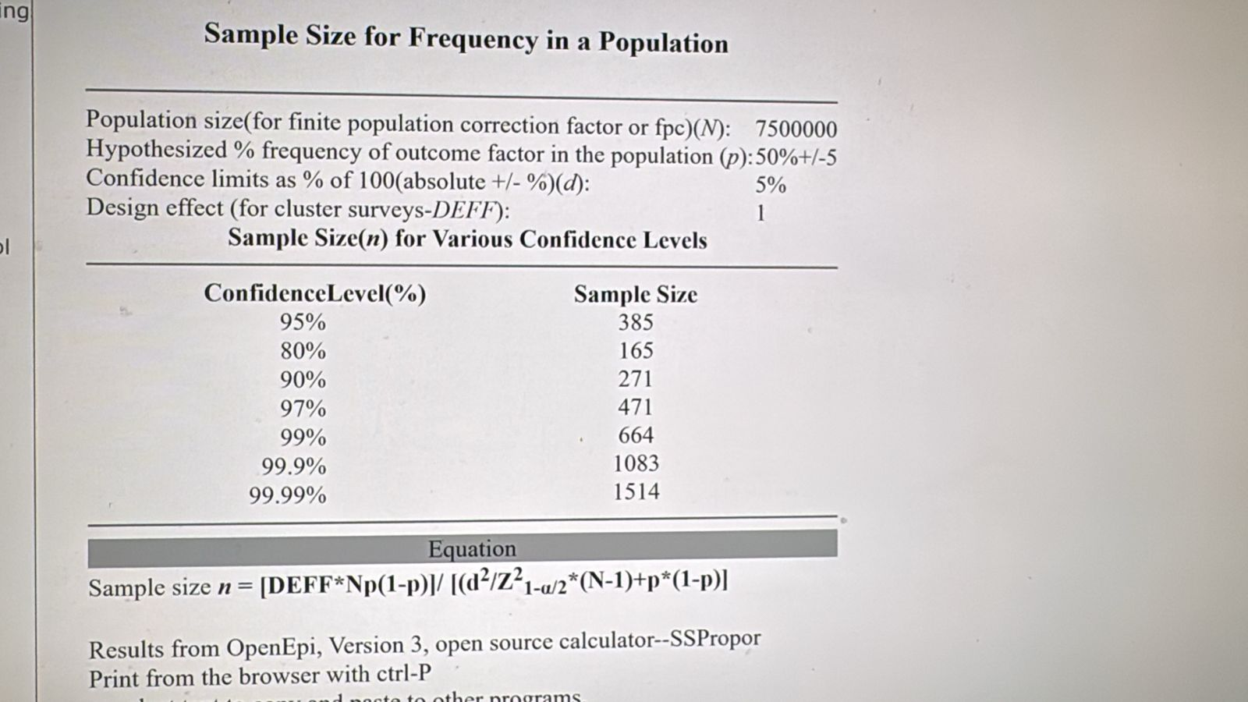
- Parijat Ghatak: For a pre-post experimental design with a prevalence rate of 7% what should be the sample size for a pilot study
Use the single-proportion CI formula (95% CI, normal approx):
$$n=\frac{Z_{1-α/2}^{2} p(1-p)}{d^{2}}$$
with $Z_{1-α/2}=1.96$for 95% confidence, $p=0.07$, and $d$= desired half-width (margin of error).
Computed sample sizes (rounded up):
- For margin $d=±5\%$(±0.05): n ≈ 101
- For margin $d=±3\%$: n ≈ 278
- For margin $d=±2\%$: n ≈ 626
- For margin $d=±1\%$: n ≈ 2501
Interpretation: if you are willing to accept a wide CI (±5 percentage points), about 100 participants are needed to estimate a 7% prevalence with 95% confidence.
2) If your pilot’s goal is to observe some events (so you can estimate feasibility/variability)
With rare events, you may want a minimum number of events (e.g., ≥5 or ≥10) to get any usable information.
Expected number of events = $n×p$.
So to expect:
- ≥5 events → $n≥5/0.07≈72$
- ≥10 events → $n≥10/0.07≈143$
So if you want at least 10 cases observed in the pilot, aim for ~140 participants.
3) If your pilot’s goal is feasibility / logistics / testing procedures (not precise prevalence)
Common practical rules of thumb for pilot studies:
- 30 participants (minimum) — good for feasibility testing and to detect gross problems.
- 30–50 typical for simple pilot feasibility studies.
These are not intended to give precise prevalence estimates but are often sufficient to judge recruitment, acceptability, and data collection methods.

- Devanshi Joshi: Sir, is there like 80% of variability sample size decreases when for 50% is it more
In 80% - there is 80% population homogenous and 20% variability. So less sample size. When 50% variabitlity, more sample size is required
- Pothiraj Pitchai: If I am interested in conducting normative data eg BP for 20-60 years. how do we do sample size calculation

- Devanshi Joshi: I mean if variability increases to 50% sample size increase, however, if variability approaches to 80%, will the sample size decrease or increase??
- Parijat Ghatak: For a pre-post experimental design cross-sectional study with a prevalence rate of 7%, what should be the sample size for a pilot study?
- Amit Tirpude: Sir my study - unveiling the Underpinning Factors and Complexity in Individual Perspectives to Register as Whole-Body Donors in Chhattisgarh: A Mixed Model Approach. Tool: questionnaire for Qn part. - how should I approach?
- Parijat Ghatak: For a pre-post experimental design with a prevalence rate of 7%, what should be the sample size for a pilot study?
If your pilot’s goal is to estimate the prevalence with a given precision
Use the single-proportion CI formula (95% CI, normal approx):
$$n=\frac{Z_{1-α/2}^{2} p(1-p)}{d^{2}}$$
with $Z_{1-α/2}=1.96$for 95% confidence, $p=0.07$, and $d$= desired half-width (margin of error).
Computed sample sizes (rounded up):
- For margin $d=±5\%$(±0.05): n ≈ 101
- For margin $d=±3\%$: n ≈ 278
- For margin $d=±2\%$: n ≈ 626
- For margin $d=±1\%$: n ≈ 2501
Interpretation: if you are willing to accept a wide CI (±5 percentage points), about 100 participants are needed to estimate a 7% prevalence with 95% confidence.
2) If your pilot’s goal is to observe some events (so you can estimate feasibility/variability)
With rare events, you may want a minimum number of events (e.g., ≥5 or ≥10) to get any usable information.
Expected number of events = $n×p$.
So to expect:
- ≥5 events → $n≥5/0.07≈72$
- ≥10 events → $n≥10/0.07≈143$
So if you want at least 10 cases observed in the pilot, aim for ~140 participants.
3) If your pilot’s goal is feasibility / logistics / testing procedures (not precise prevalence)
Common practical rules of thumb for pilot studies:
- 30 participants (minimum) — good for feasibility testing and to detect gross problems.
- 30–50 typical for simple pilot feasibility studies.
These are not intended to give precise prevalence estimates but are often sufficient to judge recruitment, acceptability, and data collection methods.
4) Recommendations for your situation (7% prevalence)
- If the pilot’s aim is only feasibility (can we recruit, measure, deliver intervention): use 30–50 participants.
- If you want a rough estimate of prevalence with ±5% precision → ~100 participants.
- If you want to observe at least ~10 outcome events (useful for estimating variability or event rates) → ~140–150 participants.
- If you need tighter precision (±3% or better) → plan a full study sized at 278+.
Also remember to inflate for expected non-response / dropouts (e.g., 10% dropout → divide n by 0.9).
5) Quick checklist to decide
- What is the primary aim of the pilot? (feasibility vs estimate precision vs estimate event rate)
- Choose acceptable margin of error $d$(if estimating prevalence) or desired minimum number of events.
- Use numbers above (or the formula) and add allowance for dropout.

